Below you will find instructions for searching for existing feature requests, adding to existing feature requests, and creating new feature requests.

To access the TestTrack feature requests you will need to login to the production instance of TestTrack.

1. Launch the TestTrack Client
   1. Start > All Programs > Seapine Software > TestTrack > TestTrack Client

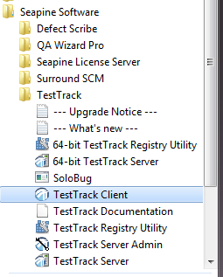

1. On the client login screen click ‘Setup’ then ‘add’ to add the connection information for the production instance

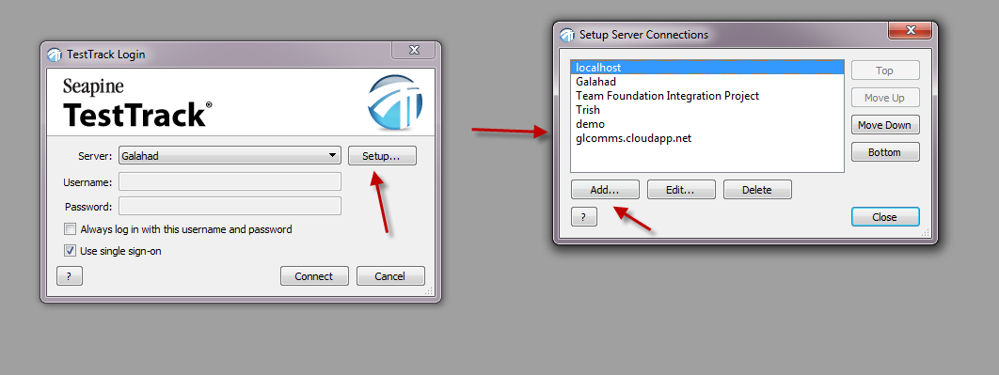

Enter the information below then click ‘Ok’  
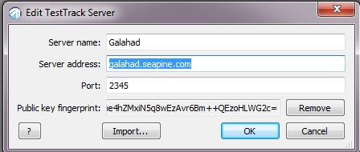

Additionally, you will need to download this public key fingerprint in order to access the production database:

[http://downloads.seapine.com/pub/support/Public Key.zip](http://downloads.seapine.com/pub/support/Public%20Key.zip). Click the ‘Import’ button and browse to the public key fingerprint once you have installed it on your machine.

Close the ‘Setup Server Connections’ window then login with the credentials you’ve been given

1. Select ‘TestTrack Bugs’ from the project dropdown
2. Once you are logged into the project select ‘Defects’ from the toolbar or go to View > Defects



1. Using the ‘Quick Find’ toolbar is the easiest way to search for feature requests. If it is not already visible in your client, you can right-click in the toolbar area and select Toolbars > Quick Find

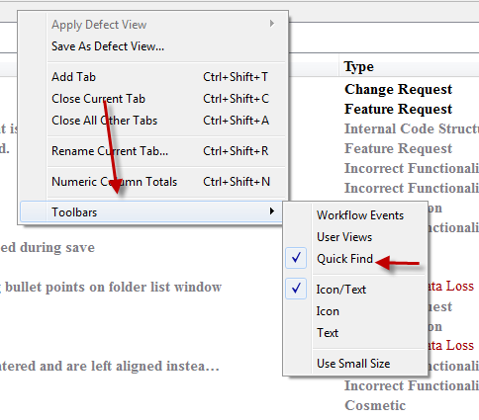

In the tool bar you will want to make sure you select ‘All Text’ in the dropdown, this will search through all the text in the defects for the keywords you type in.



1. Before you begin searching make sure the list window is set to ‘not filtered’

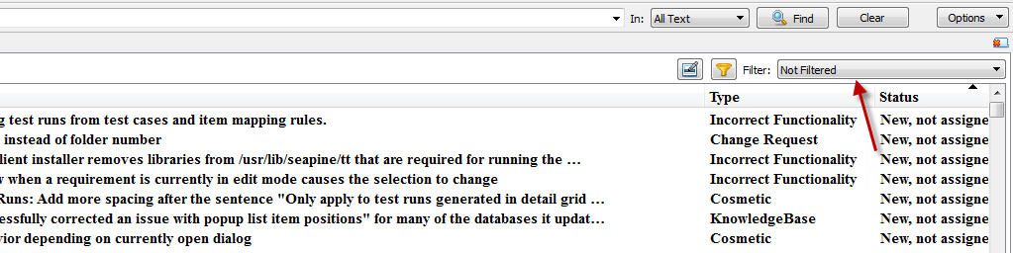

1. In this example we will search for a feature request for editing/modifying default fields. (i.e changing the product field to allow multi-select)

I suggest typing in 1 -2 words into the quick find at a time in order to return the appropriate items. If at any time you receive a message saying ‘no results found’ you can go to Edit > Advanced find and remove the last search item by clicking the ‘delete button’ then clicking ‘Find’ button to take you back to the defect list window.

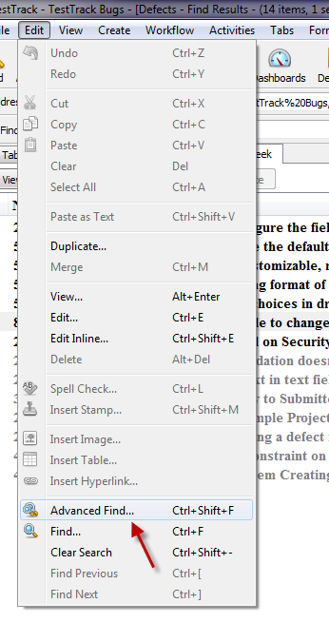

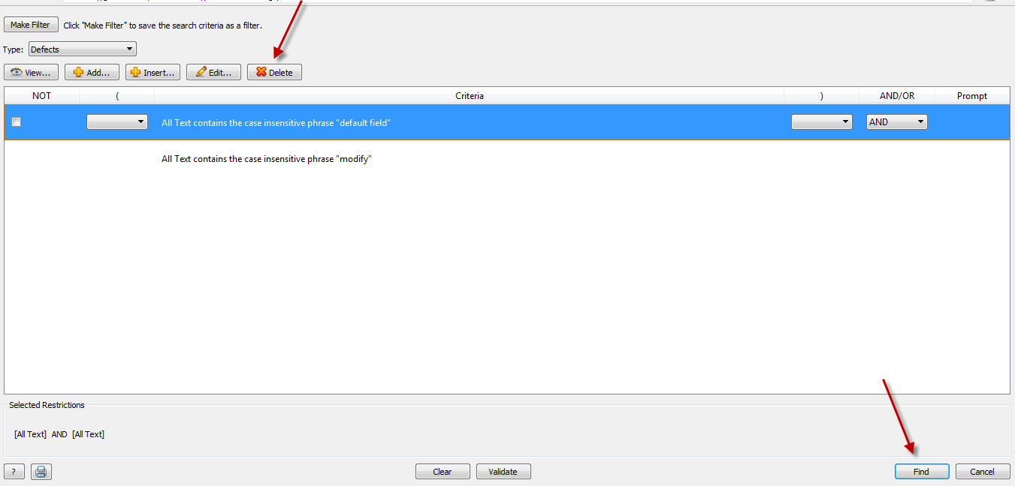

* 1. Begin by typing in the word ‘modify’ in the quick find toolbar then press the ‘enter’ key on your keyboard to narrow the search results
  2. Once the list is returned type in ‘default field’ and press ‘enter’.  
     This will return a much smaller list of results. Once you a get list this small you can read through the summaries to see what matches what you are searching for.

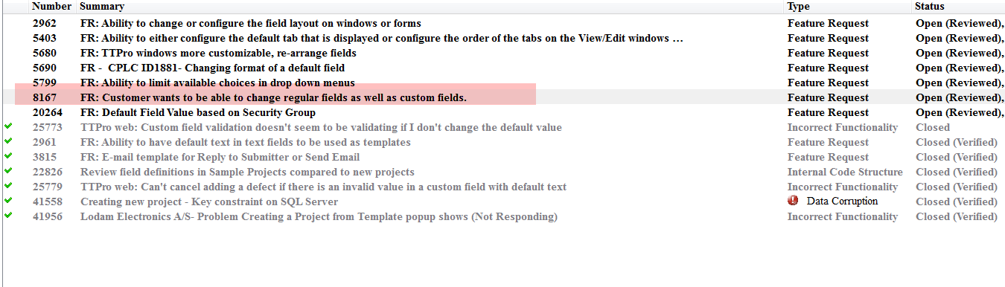

* 1. Additionally, if the need arises you can filter the list window columns to only show feature requests.
     1. To do this click the filter icon on the quick find tool bar then click the filter item on the ‘type column’ and select feature requests.  
        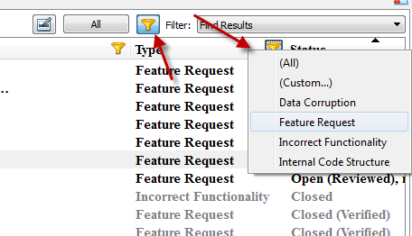

There are two ways we add a feature request.

1. Adding to an existing feature request after you have searched and found one exists.
   1. Double click on the request that was returned from your search and click the ‘Detail’ tab then click ‘New’  
      In the ‘Found by’ dropdown you will see your name, you want to change that to the customer’s name that is actually suggesting the feature request

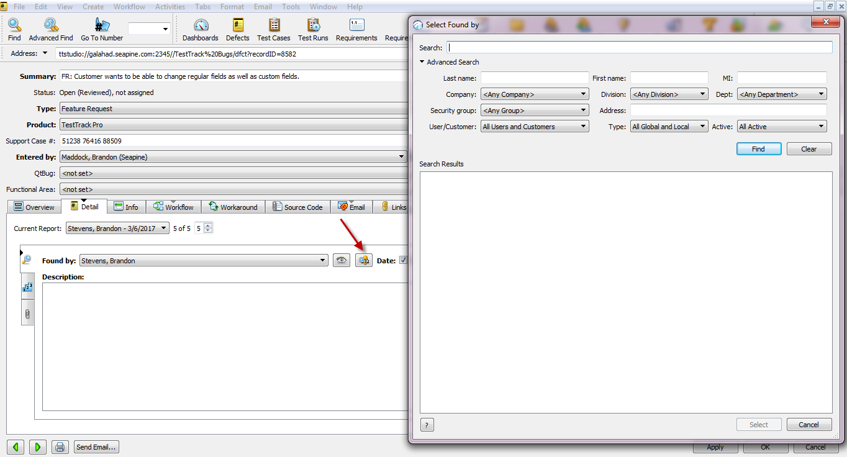

* 1. In the search box you will type the name of the customer then select the name to add them as the found by user.

**Sometimes the customer is not found and you will need to add them. To do so cancel out of the ‘Select Found by’ window and minimize the defect then go to View > Customers > Add. Fill in the first, last name. and email in the ‘Info’ tab then in the ‘Address’ tab enter the company the customer is associated with. Once you have down this you can return to the defect and search for the customer again.**

* 1. After this you will be taken back to the defect where you can fill in the description with what the customer is requesting. Most times we just copy/paste emails directly from the customer that explains what feature they want and how it will benefit their business needs. It is important to also add the case number to the defect.

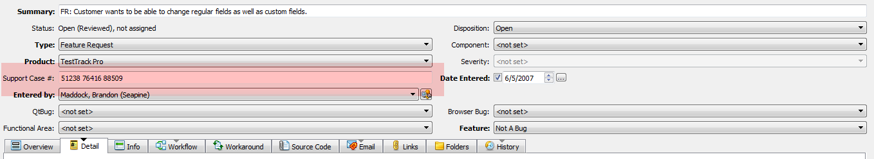

Click ‘Ok’ to save the changes

**\*\*include the URL to the feature request in the Salesforce case\*\*\***

1. Adding a new request after you have searched the project and found no matches for an existing feature requests.
   1. Click ‘Add’ on the defect list window
   2. Give the feature request a descriptive summary
   3. Fill in the required bold fields
      1. Type – Feature Request
      2. Feature – Not a Bug
      3. Found by and product will already be filled in
   4. Follow the steps above to search for the customer and fill in the description

